Chapter 8 Machines
extra worksheet 3: How were the pyramids constructed?
Science as a human endeavour Verbal/Linguistic
Name: Class: Date:
The great pyramid of Giza, near Cairo, Egypt, was constructed some 4500 years ago. It is believed to have been built by more than 20 000 workers, over a period of 20 years. The pyramid consists of approximately 2 million stone blocks with an average mass over 2 tonnes. It was developed to hold a tomb for the pharaoh Khufu, who ruled Egypt from 2589 to 2566 bc.
It is a wonder of engineering how ancient pyramid builders cut, shifted and raised the heavy blocks of stone from which this and other pyramids were built. Some people have even suggested that aliens built the pyramids.
Most scientists believe that a system of ramps was used to transport these stone blocks. They have not agreed on how these ramps were used, and a number of theories exist to try to provide an explanation.

Theory 1 – Single ramp
The pyramid of Giza stands almost 150 metres high. If a single ramp was used, it would need to have an incline no greater than 8 per cent, otherwise it would be too steep to use. For a single ramp to reach the top of the pyramid it would need to be more than 1 km long, and would require as much stone to construct as the pyramid itself. This theory seems unlikely.

Theory 2 – External spiral ramp
Instead of using a single ramp, it is more likely that a ramp may have spiralled around the pyramid. However, this theory means that the outer edges of the pyramid would not have been visible because they would have been covered by the ramp and scaffolding. The pyramid builders would have needed to check the angles of construction to ensure the pyramid came to a point at the top. As a result, this theory is also questioned.

Theory 3 – Internal ramps
While watching a documentary about the construction of the pyramids in 1999, Henri Houdin, a retired French civil engineer commented that: ‘If I had to build one now, I would build it from the inside out’. His son Jean-Paul, an architect, travelled to Egypt and created detailed 3-D computer models to investigate whether the pyramids could have been constructed using a system of internal ramps. The diagram on the following page outlines the steps in Jean-Paul Houdin’s internal ramp theory. Jean-Paul hopes to gain permission to explore the site to try to find evidence of internal ramps and tunnels in the pyramid over the years to come.
As yet, we still don’t know if any of these theories are correct and there is much debate about the issue. As new theories are proposed and tested, we move a little closer to unlocking a long-held secret.
1 State:
a how long the pyramid of Giza took to build.

b how many builders assisted in the project.

c how many stones were used.

d the average mass of these stones.

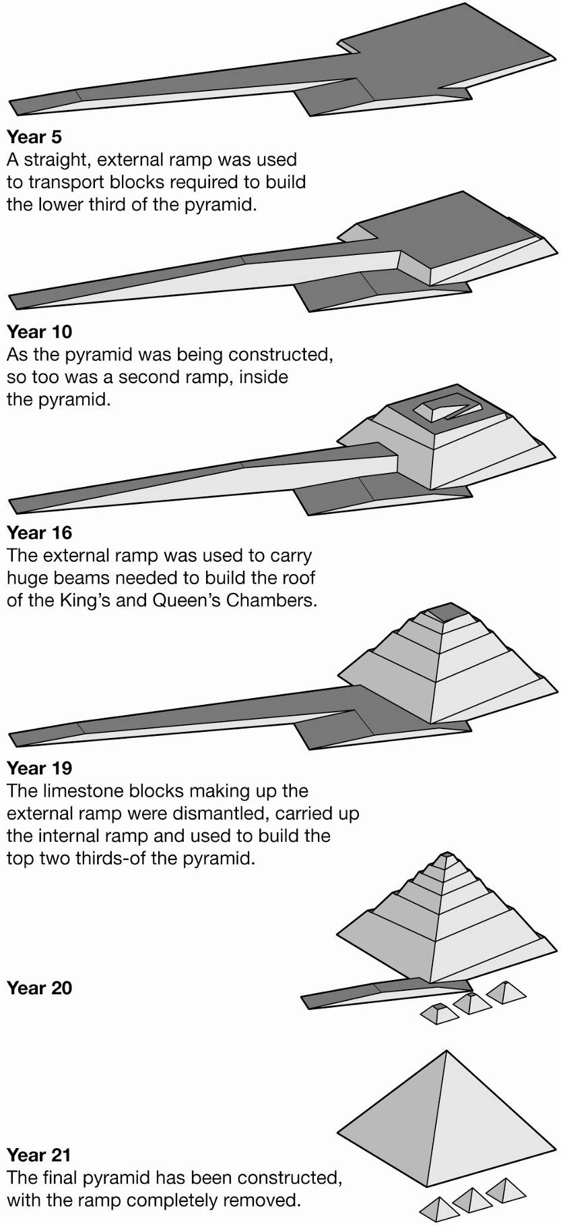

2 If a single ramp was used, explain why it could not be constructed with an incline greater than 8 per cent.

3 Outline the major problem with the single ramp theory.

4 Using a ramp that spiralled around the pyramid also presents a key problem. Outline this problem.

5 Houdin’s theory sprung from a comment his father made while watching a television documentary. Discuss what this tells us about scientific discovery.

6 Use the diagram on the previous page to answer the following questions about Jean-Paul Houdin’s theory.
a What was the purpose of the straight ramp used for the first 16 or so years of the pyramid’s construction?

b Explain what happened to the limestone blocks that made up this ramp.

